Transverse Section

Definition
# Source: AI Source: Provided by: [Data Path: Persons Table -> ID Column: 1, Name_En Column: Motasem Essam] -> From: [ChatGPT] on [7/25/2026]
A Transverse Section is a two-dimensional geometric region obtained by cutting a three-dimensional solid with a plane that is perpendicular to its longitudinal axis or principal direction of length.
It represents the shape of the solid when viewed or cut across its length.
A transverse section is commonly used to examine the width, thickness, internal structure, and cross-sectional shape of elongated solids.
It is also known as a Crosswise Section or, in many engineering and scientific contexts, simply a Cross Section.

Geometric Representation
# Source: AI Source: Provided by: [Data Path: Persons Table -> ID Column: 1, Name_En Column: Motasem Essam] -> From: [ChatGPT] on [7/25/2026]
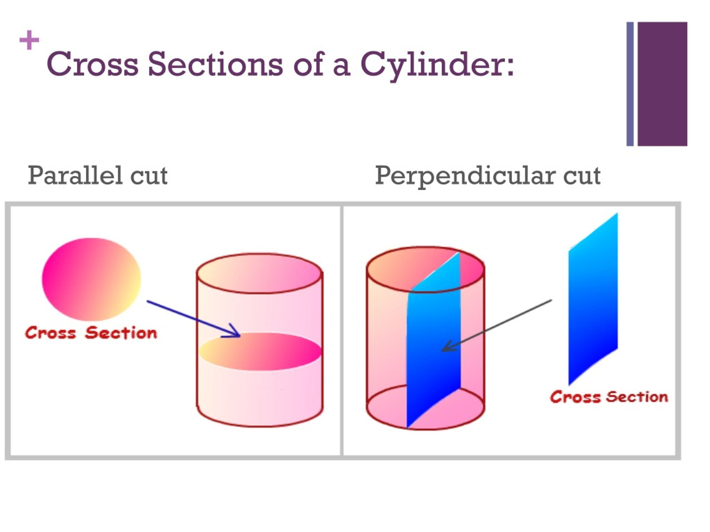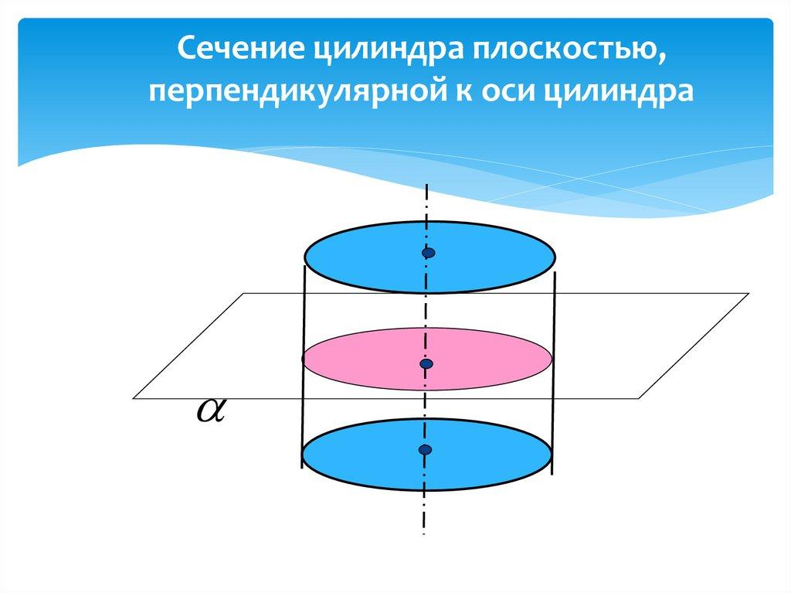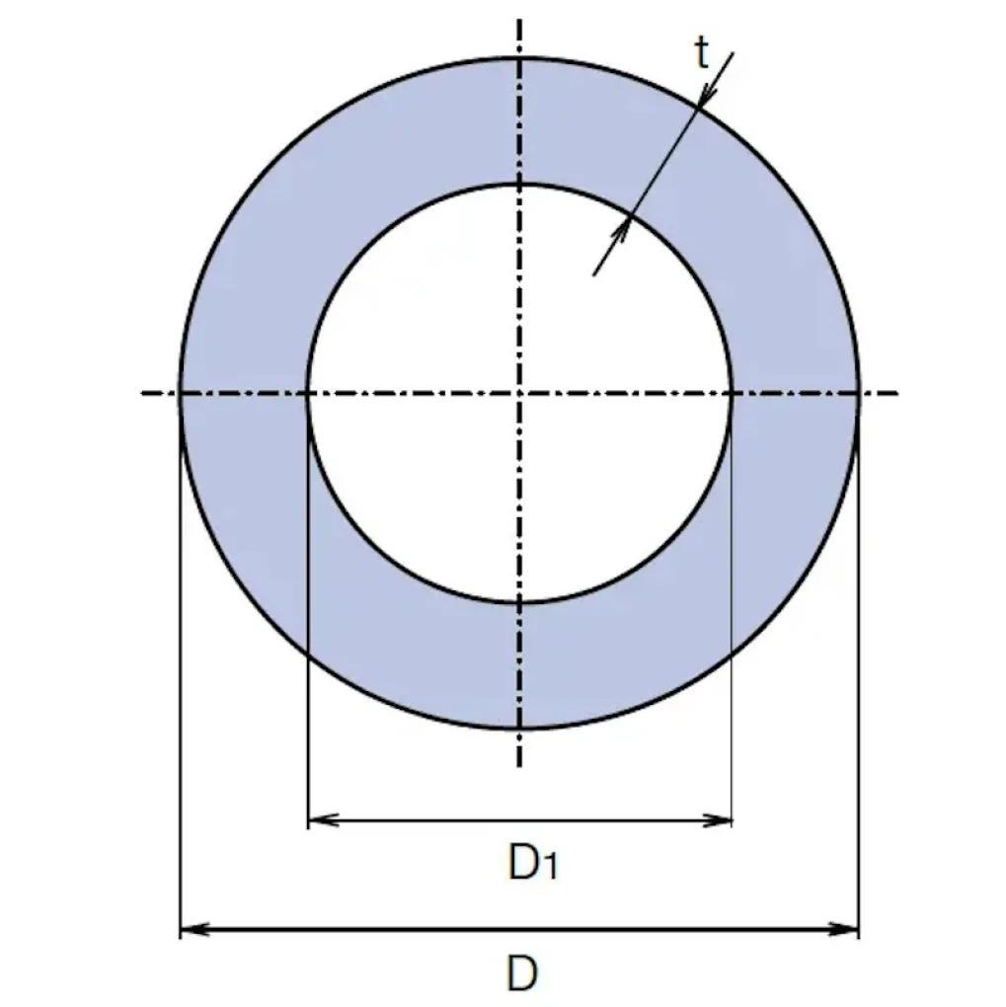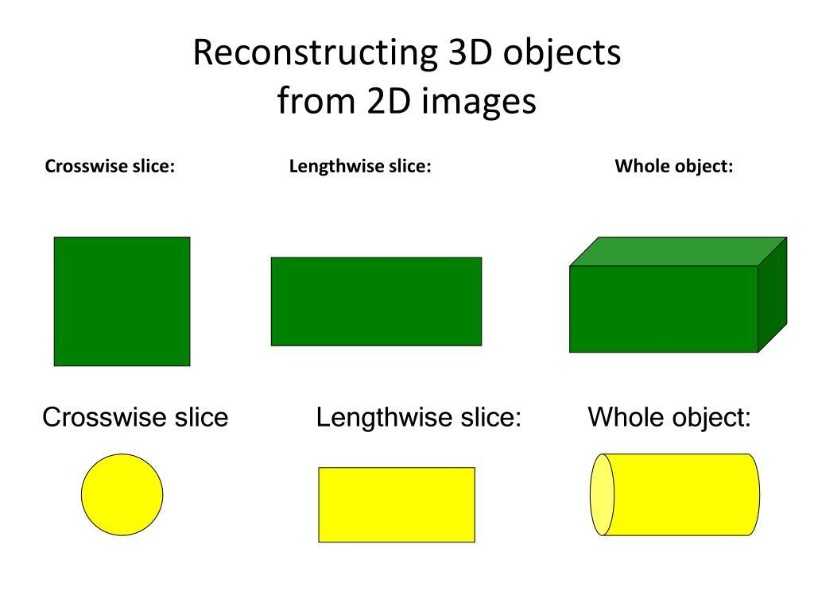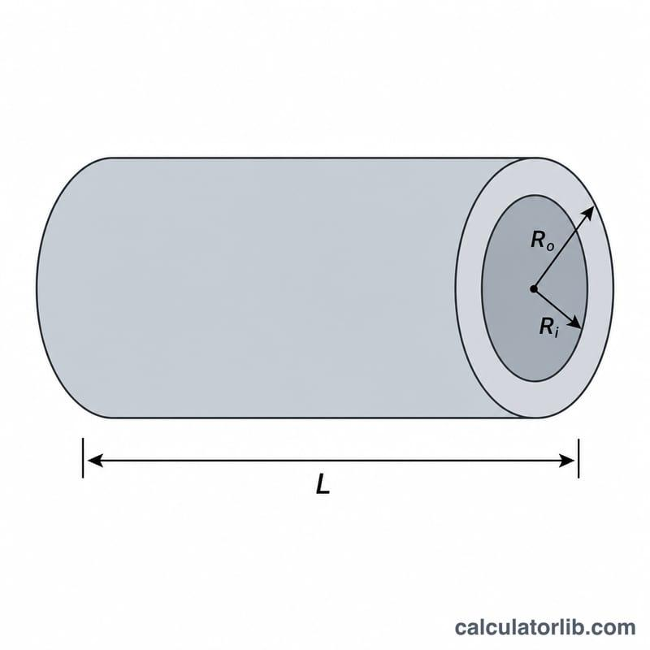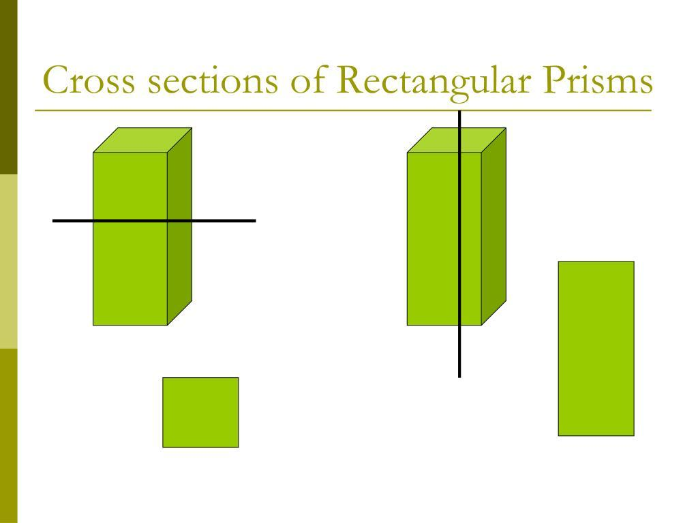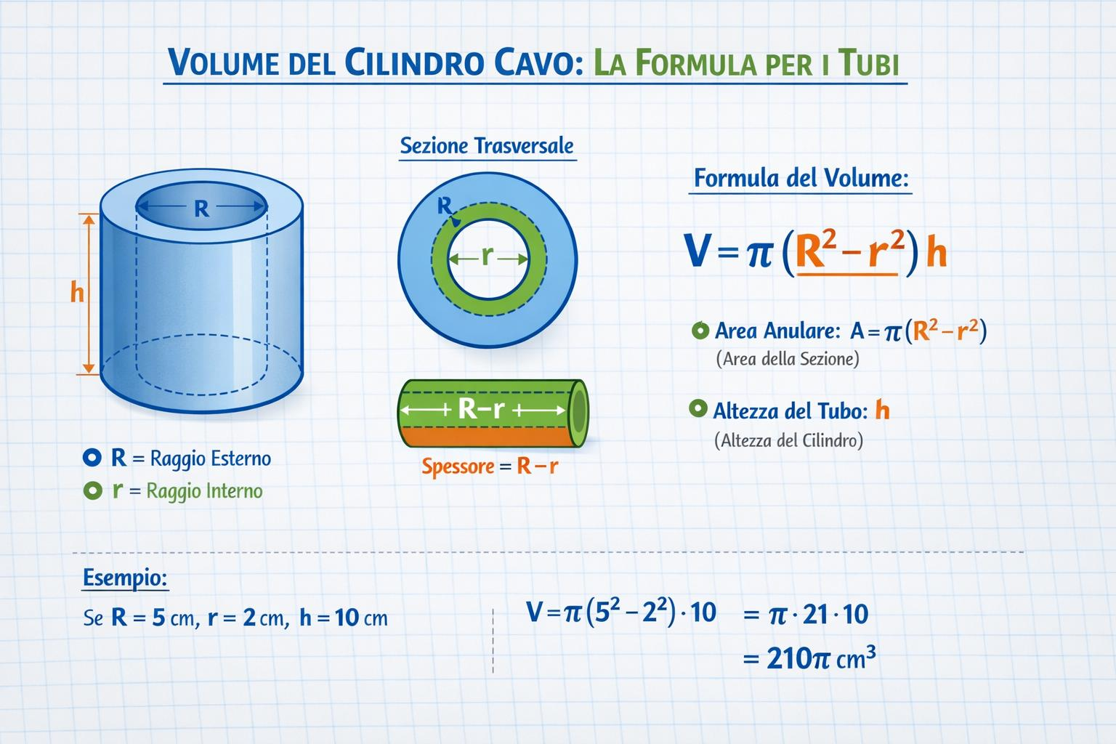
A transverse section is created by passing a cutting plane across the solid, perpendicular to its longitudinal axis.
For an elongated solid, the cutting plane generally intersects the solid's length at a particular position and reveals its cross-sectional profile.

Geometric Structure
# Source: AI Source: Provided by: [Data Path: Persons Table -> ID Column: 1, Name_En Column: Motasem Essam] -> From: [ChatGPT] on [7/25/2026]
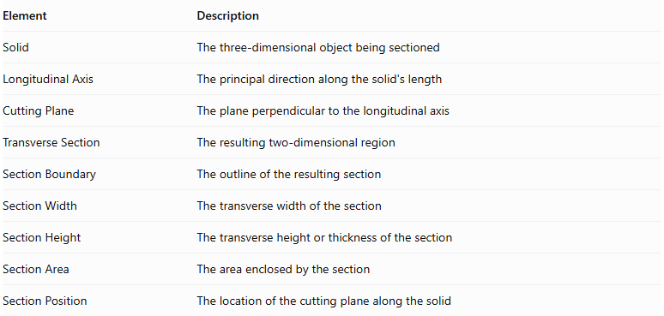
Element | Description
Solid | The three-dimensional object being sectioned
Longitudinal Axis | The principal direction along the solid's length
Cutting Plane | The plane perpendicular to the longitudinal axis
Transverse Section | The resulting two-dimensional region
Section Boundary | The outline of the resulting section
Section Width | The transverse width of the section
Section Height | The transverse height or thickness of the section
Section Area | The area enclosed by the section
Section Position | The location of the cutting plane along the solid

Main Characteristics
# Source: AI Source: Provided by: [Data Path: Persons Table -> ID Column: 1, Name_En Column: Motasem Essam] -> From: [ChatGPT] on [7/25/2026]
- The cutting plane is perpendicular to the solid's longitudinal axis.
- The section cuts across the length of the solid.
- Its shape depends on the solid's geometry and the position of the cutting plane.
- Multiple transverse sections can be taken at different positions along the same solid.
- Sections can be identical or vary in shape and dimensions along the solid.
- A transverse section normally produces a two-dimensional region.
- It is particularly useful for studying elongated solids and their internal structures.

Types of Transverse Sections According to Geometric Shape

Polygonal Transverse Sections
# Source: AI Source: Provided by: [Data Path: Persons Table -> ID Column: 1, Name_En Column: Motasem Essam] -> From: [ChatGPT] on [7/25/2026]
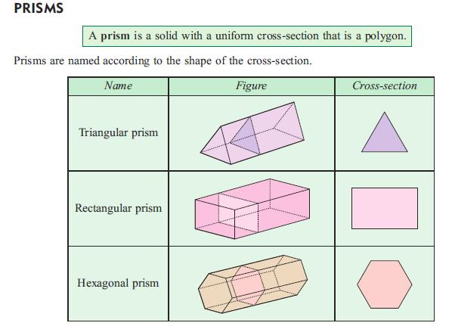
Sections bounded by straight-line segments.
Examples:
- Triangular Transverse Section
- Square Transverse Section
- Rectangular Transverse Section
- Pentagonal Transverse Section
- Hexagonal Transverse Section
- Irregular Polygonal Transverse Section

Circular Transverse Sections
# Source: AI Source: Provided by: [Data Path: Persons Table -> ID Column: 1, Name_En Column: Motasem Essam] -> From: [ChatGPT] on [7/25/2026]
Sections bounded by a circular circumference.
Examples:
- Solid Circular Transverse Section
- Circular Transverse Section of a Cylinder
- Circular Transverse Section of a Cone

Elliptical Transverse Sections
# Source: AI Source: Provided by: [Data Path: Persons Table -> ID Column: 1, Name_En Column: Motasem Essam] -> From: [ChatGPT] on [7/25/2026]
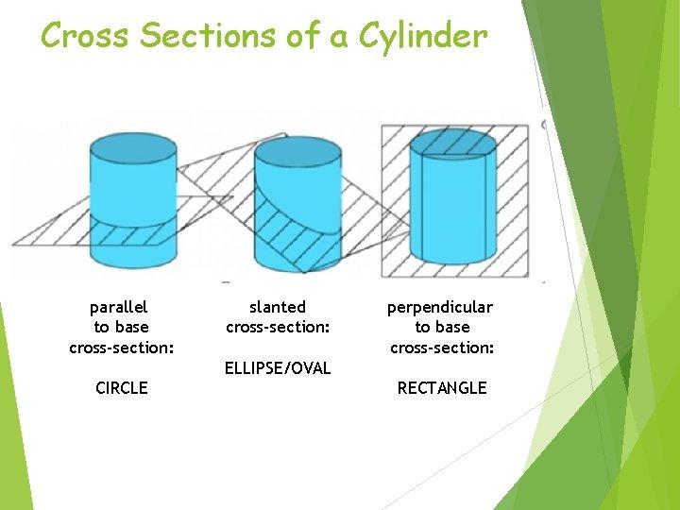
Sections bounded by an ellipse.
Examples:
- Elliptical Transverse Section
- Elliptical Transverse Section of an Elliptic Cylinder
- Elliptical Transverse Section of an Ellipsoid

Annular Transverse Sections
# Source: AI Source: Provided by: [Data Path: Persons Table -> ID Column: 1, Name_En Column: Motasem Essam] -> From: [ChatGPT] on [7/25/2026]
Ring-shaped sections bounded by two concentric circles.
Examples:
- Annular Transverse Section of a Hollow Cylinder
- Annular Transverse Section of a Pipe
- Annular Transverse Section of a Cylindrical Shell

Irregular Curvilinear Transverse Sections
# Source: AI Source: Provided by: [Data Path: Persons Table -> ID Column: 1, Name_En Column: Motasem Essam] -> From: [ChatGPT] on [7/25/2026]
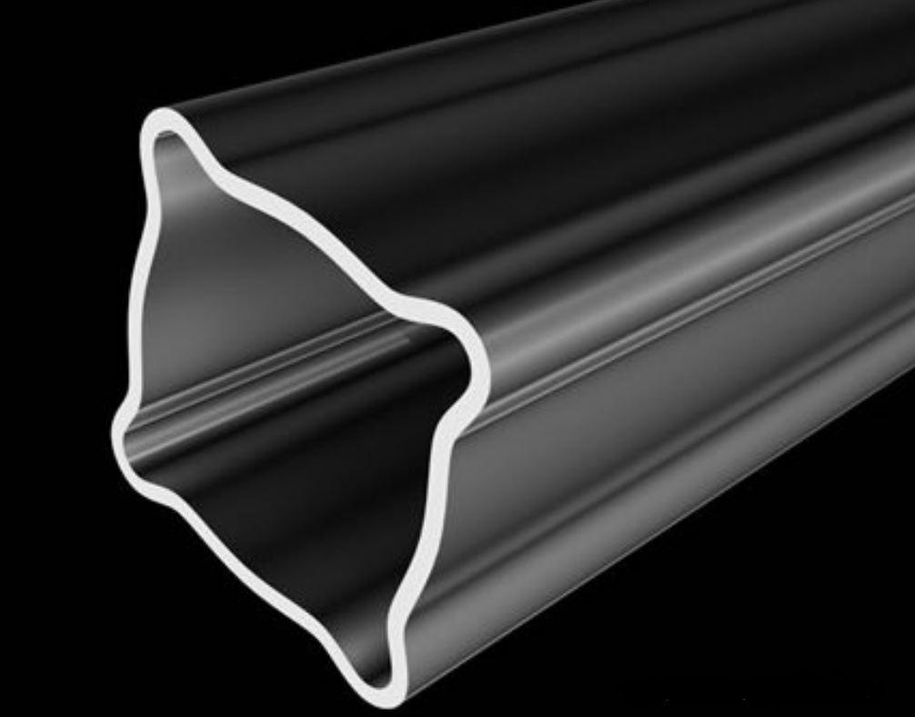
Sections whose boundaries contain curved portions that do not form standard circular or elliptical shapes.
Examples:
- Irregular Curvilinear Transverse Section
- Multi-Lobed Transverse Section
- Composite Curvilinear Transverse Section

Transverse Sections According to Solid Type
# Source: AI Source: Provided by: [Data Path: Persons Table -> ID Column: 1, Name_En Column: Motasem Essam] -> From: [ChatGPT] on [7/25/2026]
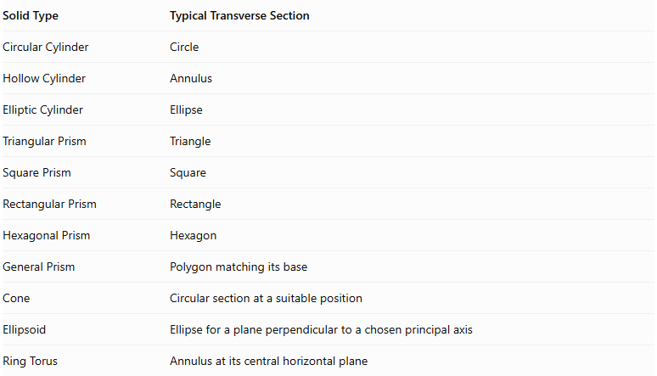
Solid Type | Typical Transverse Section
Circular Cylinder | Circle
Hollow Cylinder | Annulus
Elliptic Cylinder | Ellipse
Triangular Prism | Triangle
Square Prism | Square
Rectangular Prism | Rectangle
Hexagonal Prism | Hexagon
General Prism | Polygon matching its base
Cone | Circular section at a suitable position
Ellipsoid | Ellipse for a plane perpendicular to a chosen principal axis
Ring Torus | Annulus at its central horizontal plane
Important: These are typical examples, not universal results. The shape depends on the selected longitudinal axis and the position of the cutting plane. A sphere, for example, has no unique longitudinal axis; a reference axis must be selected.

Mathematical Representation

General Plane Equation
# Source: AI Source: Provided by: [Data Path: Persons Table -> ID Column: 1, Name_En Column: Motasem Essam] -> From: [ChatGPT] on [7/25/2026]
A transverse cutting plane can be represented by:
$$ax+by+cz+d=0$$
Its normal vector is:
$$vecn=(a,b,c)$$
For a solid whose longitudinal axis is parallel to the $z$-axis, a transverse plane is perpendicular to that axis and has the form:
$$z=k$$
Where $k$ represents the position of the section along the solid.

Transverse Section as an Intersection
# Source: AI Source: Provided by: [Data Path: Persons Table -> ID Column: 1, Name_En Column: Motasem Essam] -> From: [ChatGPT] on [7/25/2026]
Let:
- $S$: three-dimensional solid.
- $P$: transverse cutting plane.
- $C$: resulting transverse section.
Then:
$$C=S∩P$$

Section Area
# Source: AI Source: Provided by: [Data Path: Persons Table -> ID Column: 1, Name_En Column: Motasem Essam] -> From: [ChatGPT] on [7/25/2026]
The area of the transverse section is:
$$A={iint}_{C}dA$$
Common area formulas include:
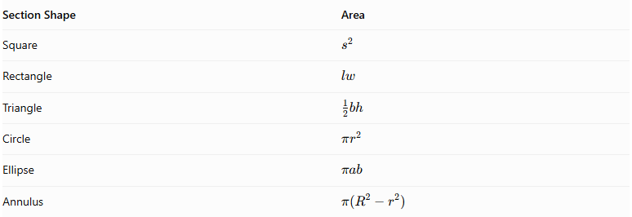
Section Shape | Area
Square | $$s^{2}$$
Rectangle | $$lw$$
Triangle | $$\frac{1}{2}bh$$
Circle | $$πr^{2}$$
Ellipse | $$πab$$
Annulus | $$π(R^{2}-r^{2})$$

Volume from Transverse Sections
# Source: AI Source: Provided by: [Data Path: Persons Table -> ID Column: 1, Name_En Column: Motasem Essam] -> From: [ChatGPT] on [7/25/2026]
For a solid extending along the $z$-axis, its volume can be calculated by integrating its transverse section areas:
$$V=\int_{a}^{b}{A(z)} dz$$
Where:
- $A(z)$: transverse section area at position $z$.
- $a,b$: beginning and ending positions along the longitudinal axis.

Comparison with Longitudinal Section
# Source: AI Source: Provided by: [Data Path: Persons Table -> ID Column: 1, Name_En Column: Motasem Essam] -> From: [ChatGPT] on [7/25/2026]
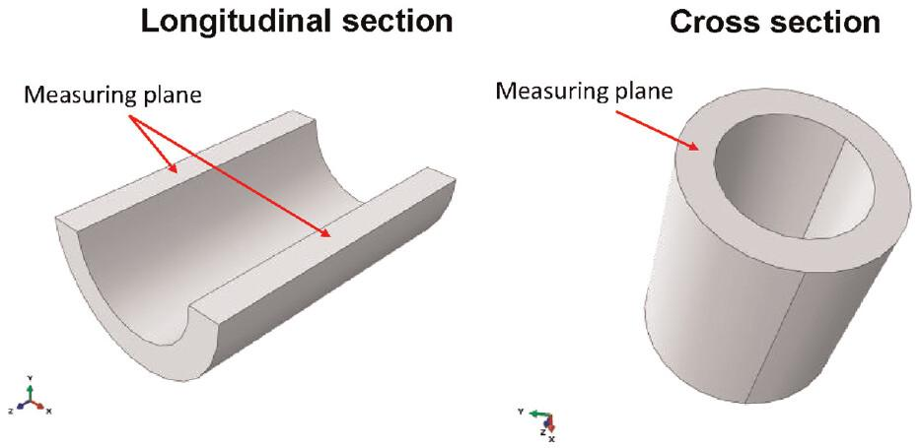
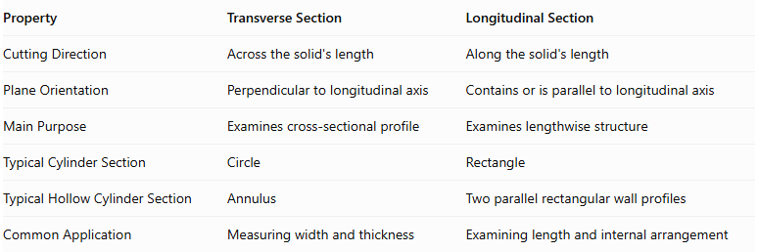
Property | Transverse Section | Longitudinal Section
Cutting Direction | Across the solid's length | Along the solid's length
Plane Orientation | Perpendicular to longitudinal axis | Contains or is parallel to longitudinal axis
Main Purpose | Examines cross-sectional profile | Examines lengthwise structure
Typical Cylinder Section | Circle | Rectangle
Typical Hollow Cylinder Section | Annulus | Two parallel rectangular wall profiles
Common Application | Measuring width and thickness | Examining length and internal arrangement

Applications
# Source: AI Source: Provided by: [Data Path: Persons Table -> ID Column: 1, Name_En Column: Motasem Essam] -> From: [ChatGPT] on [7/25/2026]
- Mechanical Engineering: Examining shafts, pipes, rods, and structural components.
- Architecture: Studying the cross-sectional profiles of structural members.
- Manufacturing: Measuring the shape and dimensions of cut materials.
- Medical Imaging: Examining transverse slices of anatomical structures.
- Geology: Studying underground formations through transverse profiles.
- Civil Engineering: Measuring road, railway, and terrain profiles.

Main Classification
# Source: AI Source: Provided by: [Data Path: Persons Table -> ID Column: 1, Name_En Column: Motasem Essam] -> From: [ChatGPT] on [7/25/2026]
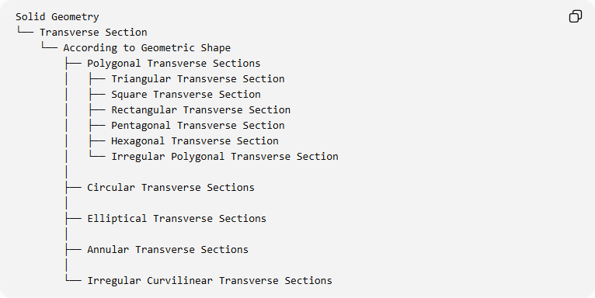
Solid Geometry
└── Transverse Section
└── According to Geometric Shape
├── Polygonal Transverse Sections
│ ├── Triangular Transverse Section
│ ├── Square Transverse Section
│ ├── Rectangular Transverse Section
│ ├── Pentagonal Transverse Section
│ ├── Hexagonal Transverse Section
│ └── Irregular Polygonal Transverse Section
│
├── Circular Transverse Sections
│
├── Elliptical Transverse Sections
│
├── Annular Transverse Sections
│
└── Irregular Curvilinear Transverse Sections

Key Points
# Source: AI Source: Provided by: [Data Path: Persons Table -> ID Column: 1, Name_En Column: Motasem Essam] -> From: [ChatGPT] on [7/25/2026]
- A transverse section is produced by cutting a solid perpendicular to its longitudinal axis.
- It reveals the solid's cross-sectional profile.
- Its shape can be polygonal, circular, elliptical, annular, or irregularly curvilinear.
- Its dimensions may remain constant or change along the solid's length.
- It differs from a longitudinal section, which runs along the solid's length.

Conclusion
# Source: AI Source: Provided by: [Data Path: Persons Table -> ID Column: 1, Name_En Column: Motasem Essam] -> From: [ChatGPT] on [7/25/2026]
A Transverse Section is an important sectional concept in solid geometry that describes the shape obtained by cutting a solid across its longitudinal direction. It provides information about the solid's cross-sectional geometry, dimensions, and internal structure, making it useful in geometric analysis, engineering, architecture, and manufacturing.

Sources
# Source: AI Source: Provided by: [Data Path: Persons Table -> ID Column: 1, Name_En Column: Motasem Essam] -> From: [ChatGPT] on [7/25/2026]
- Multilingual Technical Dictionary – Longitudinal and Transverse Sections
- Digital Histology – Section Planes
- Technical Drawing Terminology – Longitudinal Section
- Elements of Descriptive Geometry – Sections of Solids

